**Document: CentOS Installation and Virtual Machine Creation using VirtualBox**

**Steps to Create a Virtual Machine**

* Open **VMware Workstation / Player**

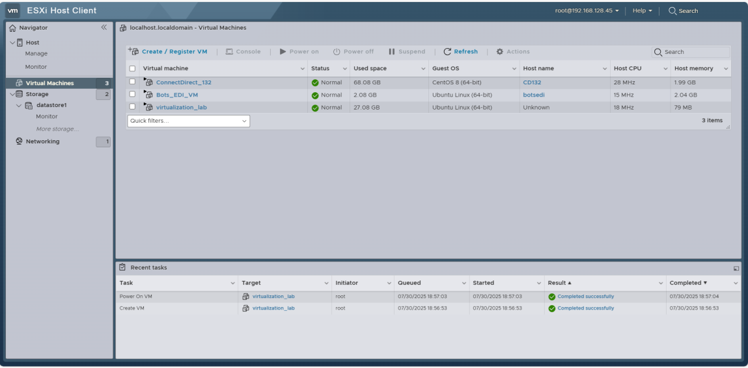

* Click **Create a New Virtual Machine and Click Next**

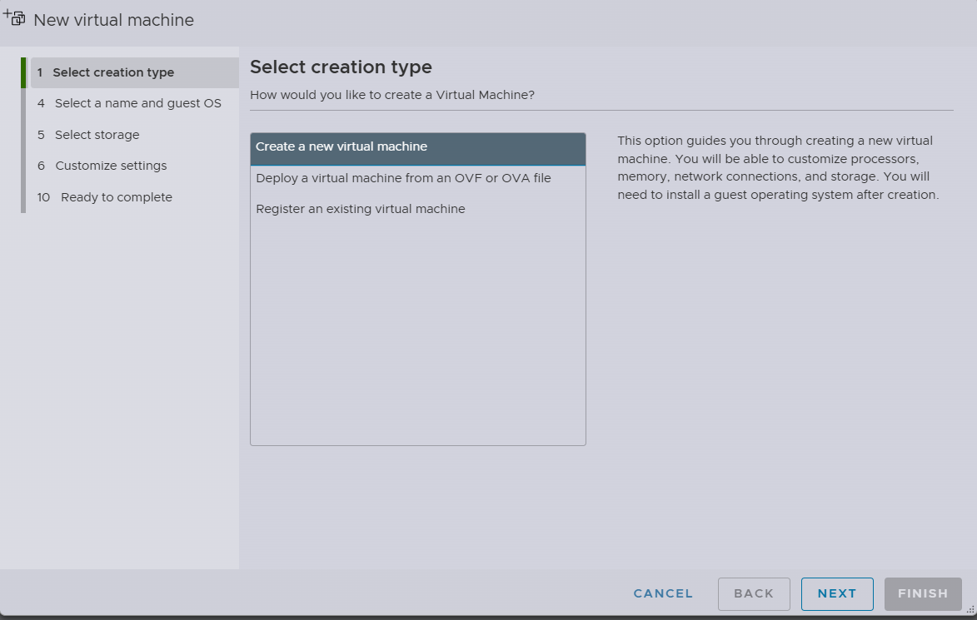

* Select a name and guest OS details , Click Next

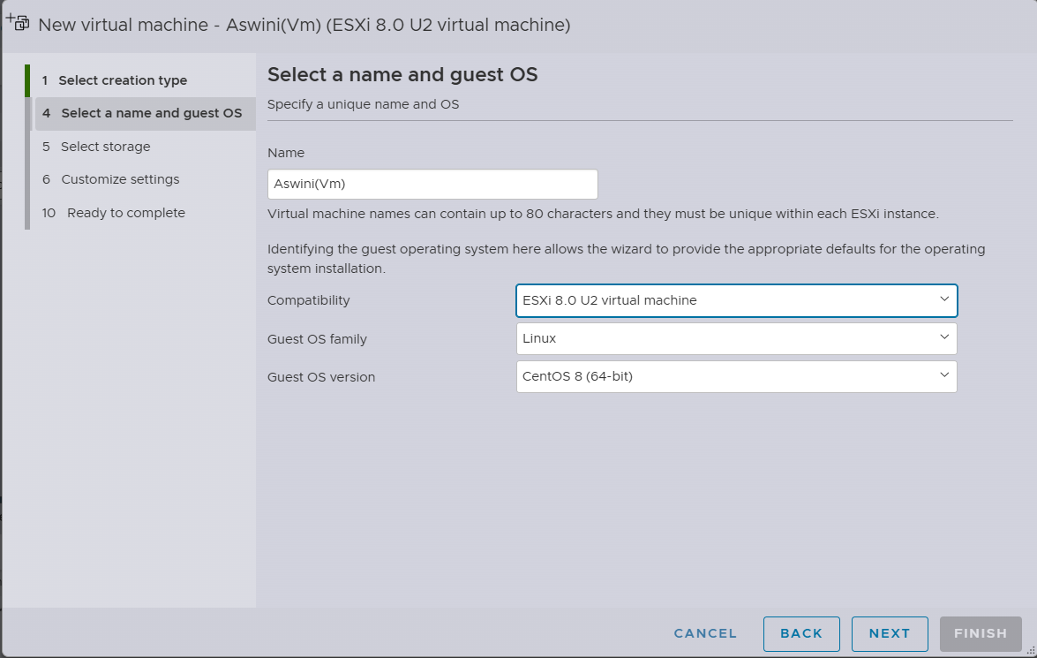

* Select storage(datastore1, datastore2), Click Next

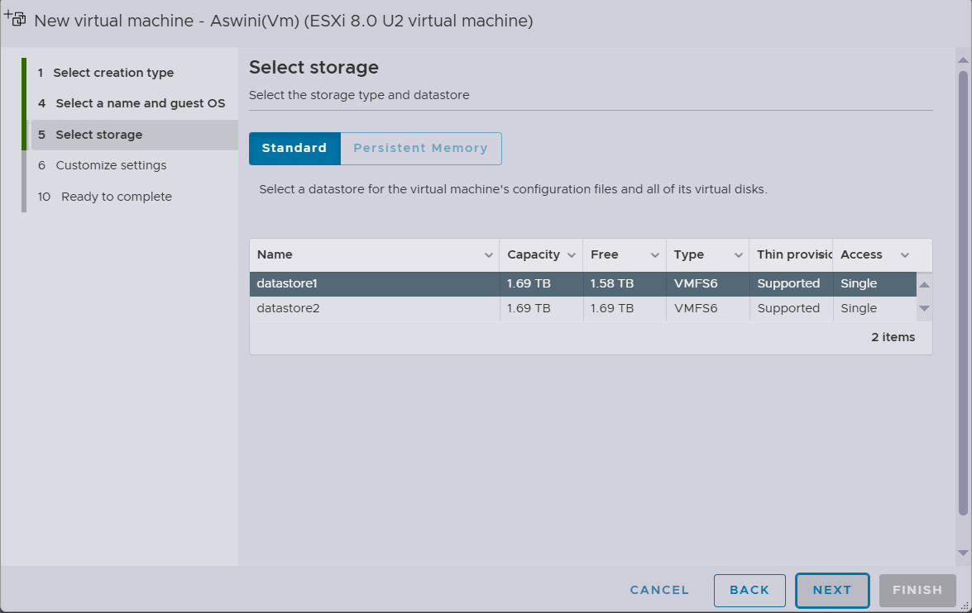

* In datstore1 🡪ISO’s 🡪centOS 🡪select

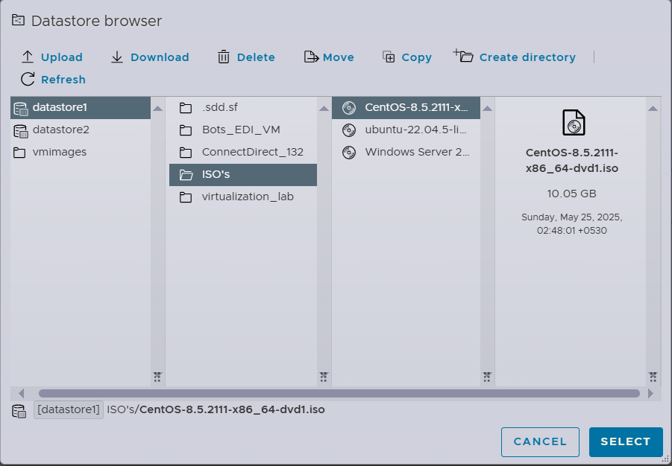

* Customize settings (virtual Hardware, VM Options) , click Next
* Select: Create a virtual hard disk now
* Type: VDI
* Storage: Dynamically allocated
* Size: 16 GB (minimum)

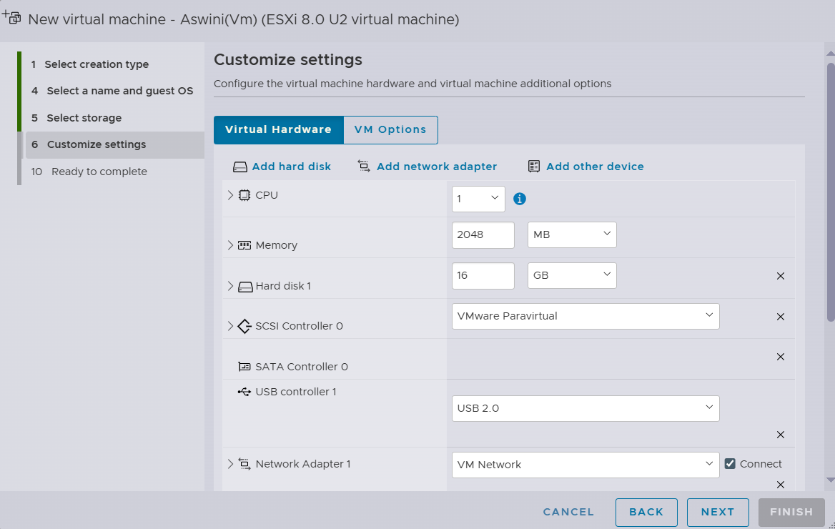

* Check the details, Now it’s Ready to complete , Click Finish

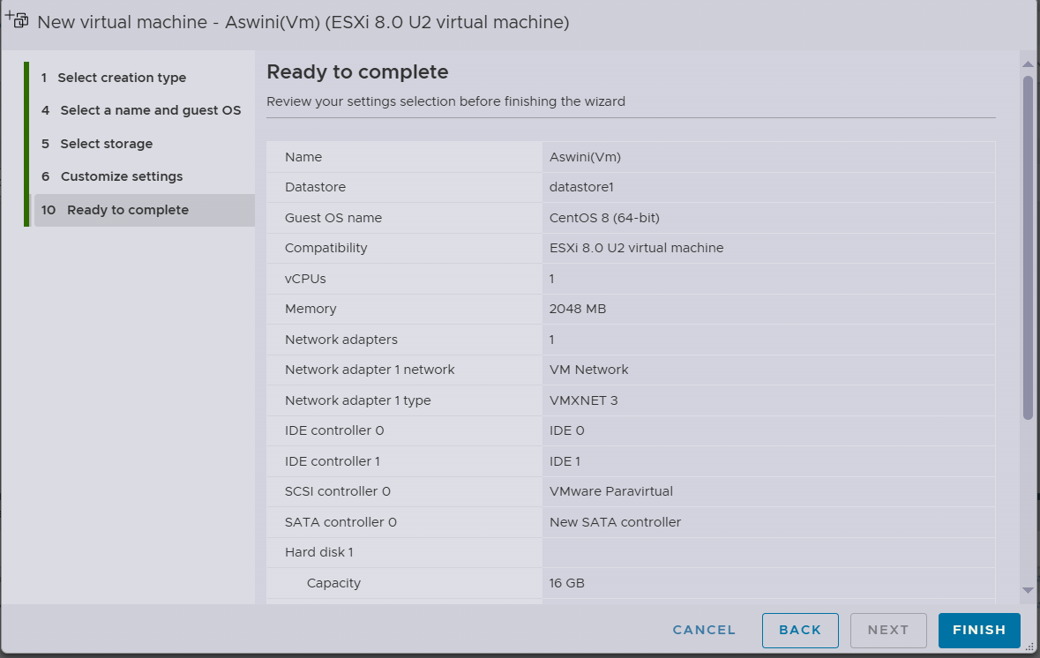

* After VM creation dashboard

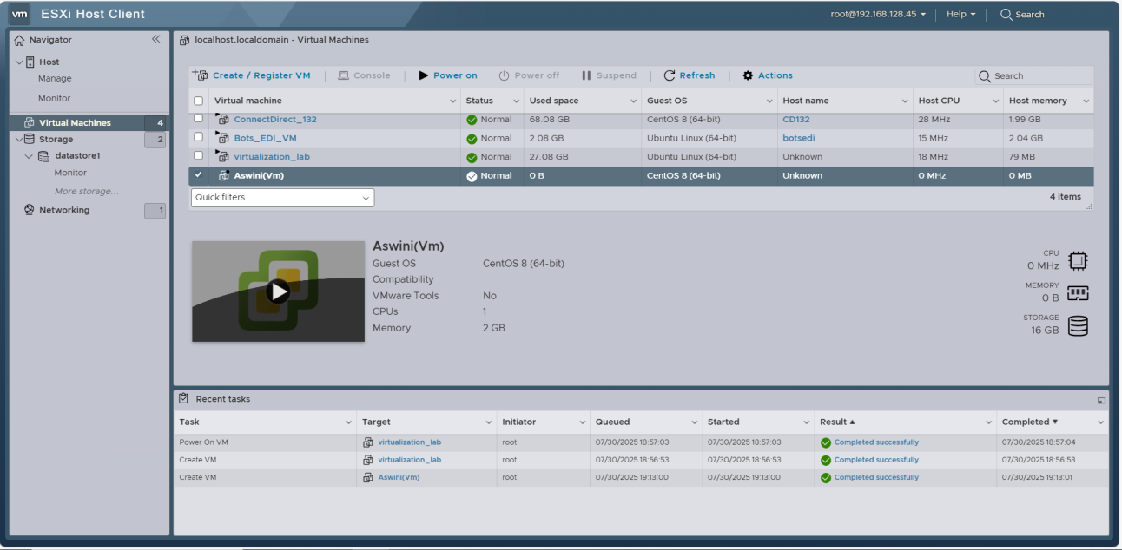

Open console, Begin Installation

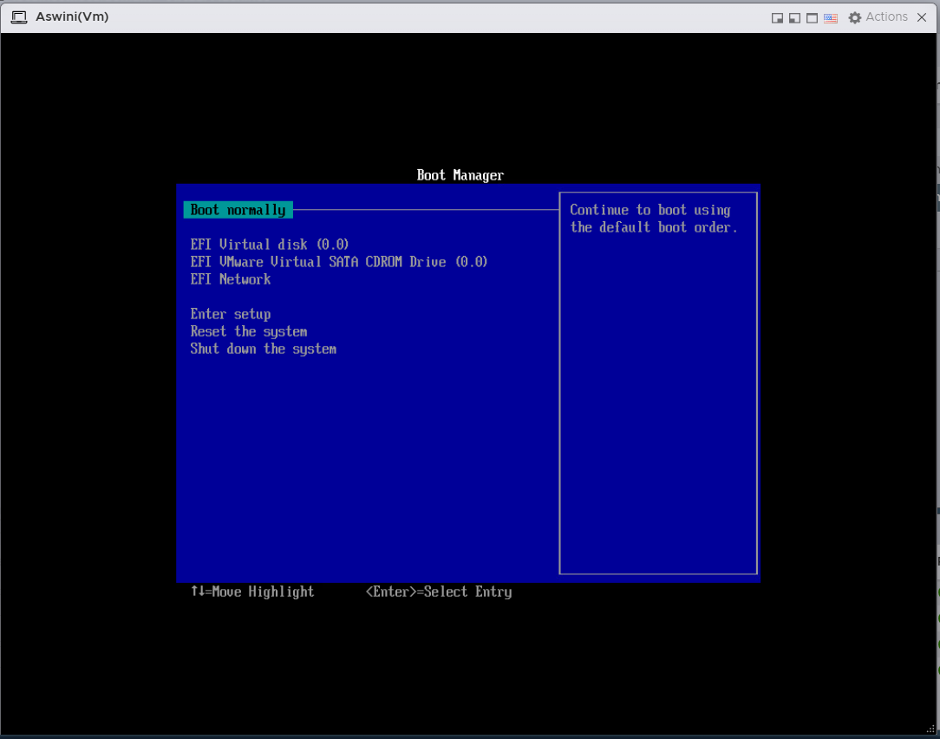

* If you see Boot normally , Click EFI VMware Virtual SATA CDRDM Drive

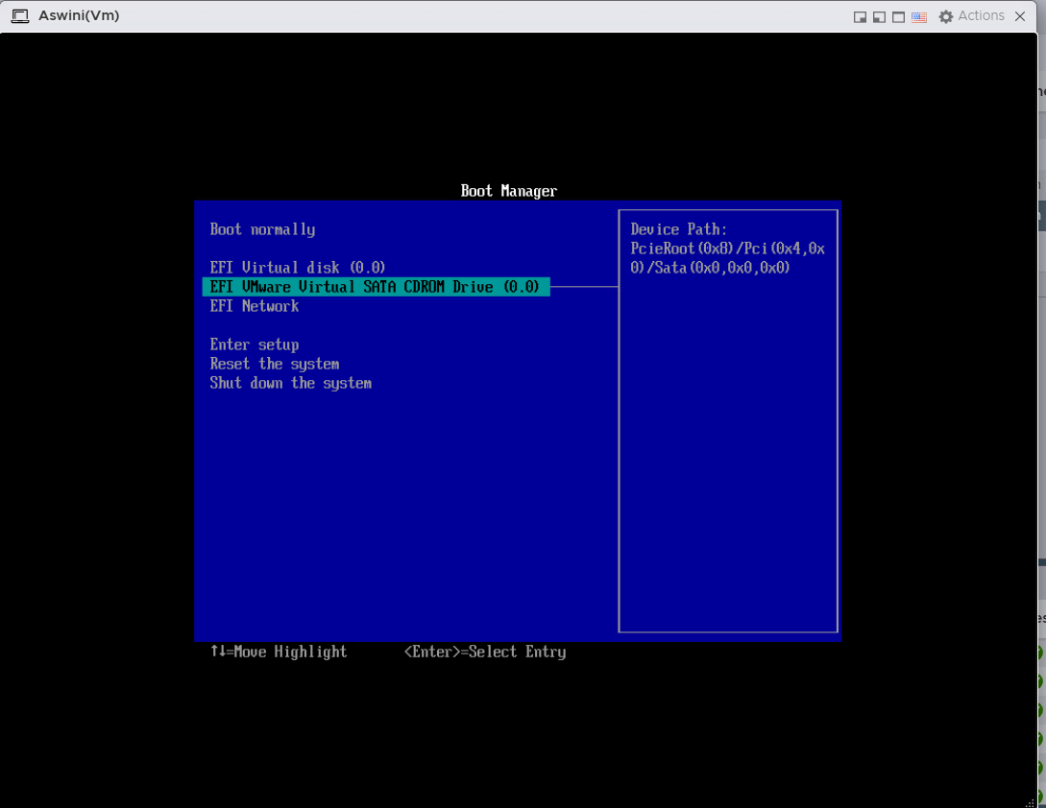

* Choose language: English
* Set Installation Destination → Select disk → Click "Done"

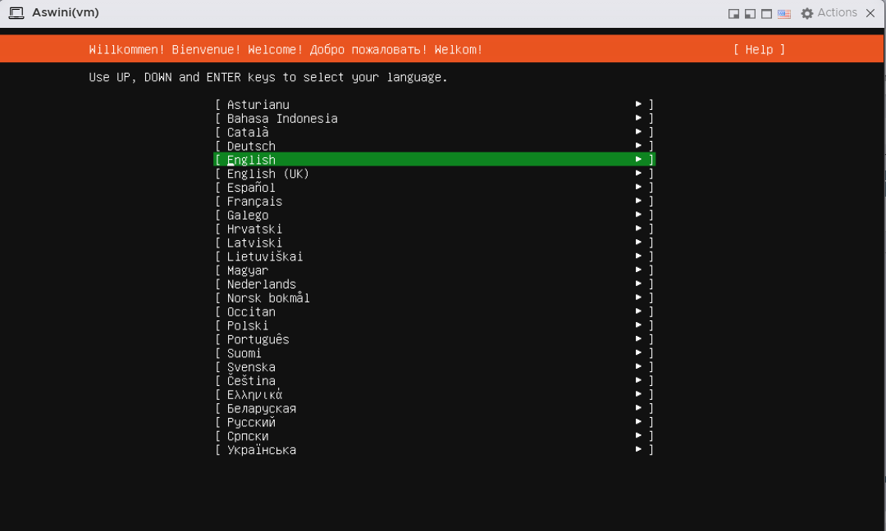

* Simply Click on “Enter” Button for Installation

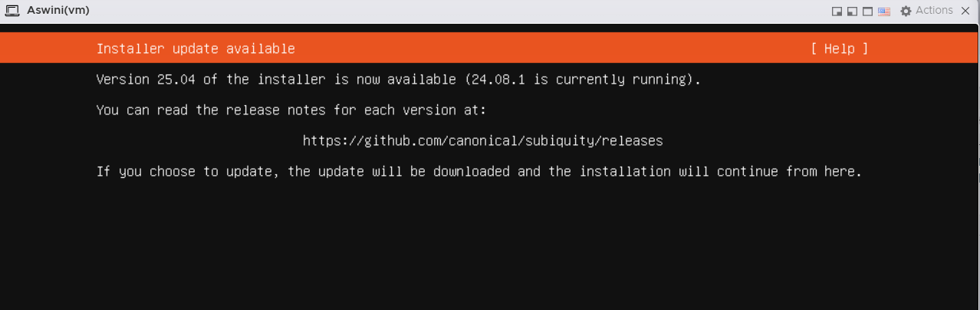

* Click on “Enter”

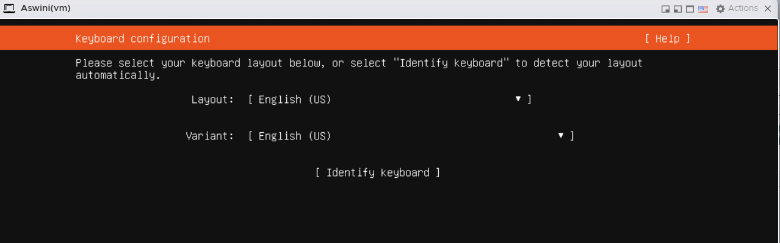

* Choose Installation type or else Click on “Enter” for default

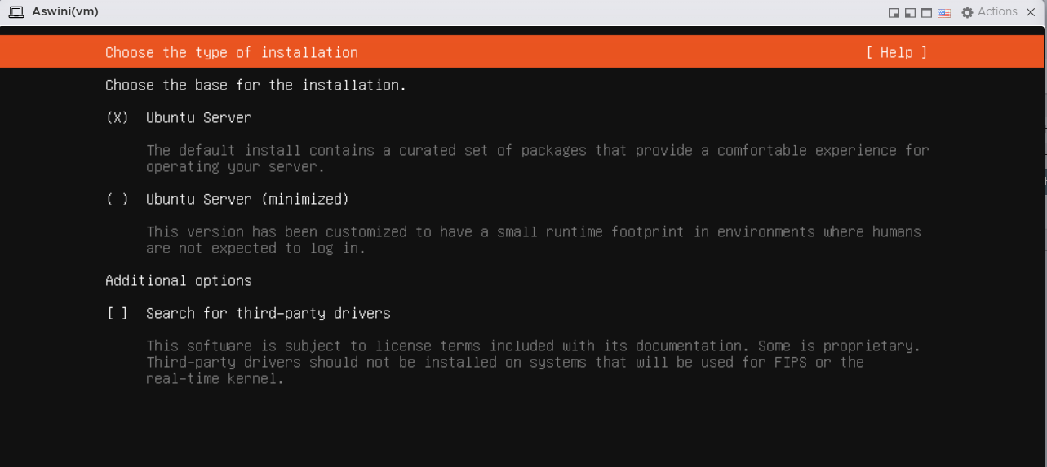

* Select ens34 for static ip, But I go for Dyanamic ip , so click on “Enter”

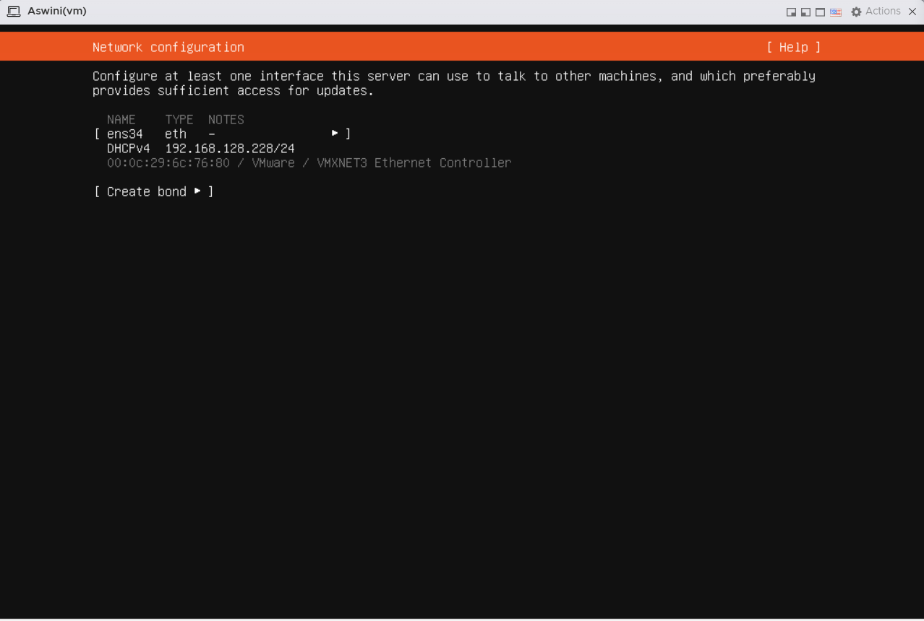

* Here we can proxy address or else go for default 🡪 Enter

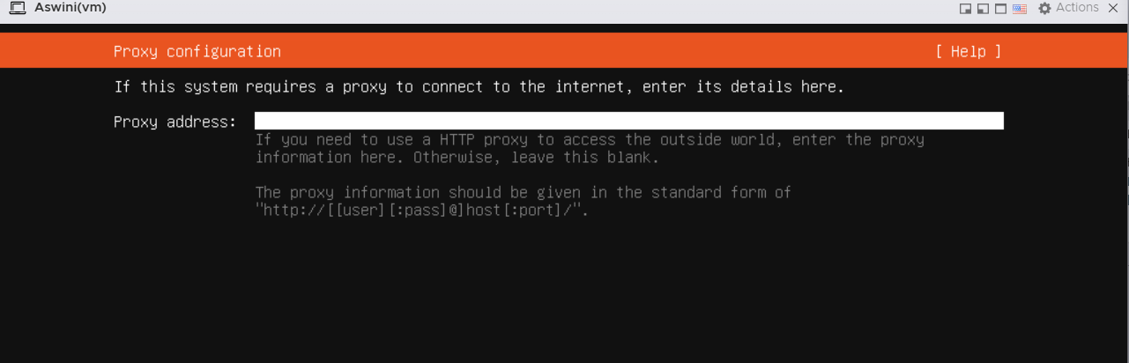

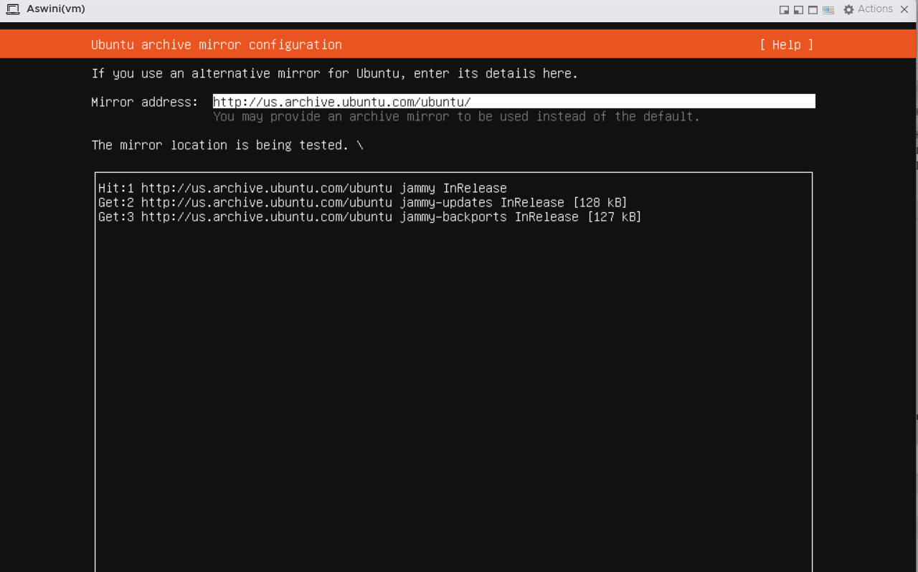

Click “Enter”

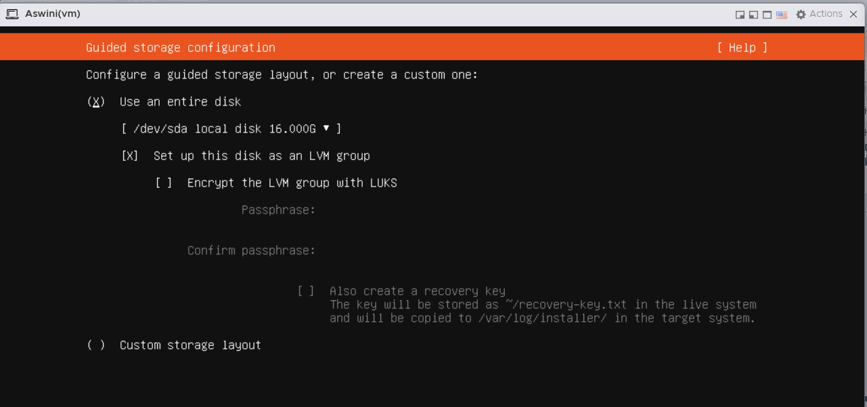

* Select Encrypt the LVM group and give passphrase

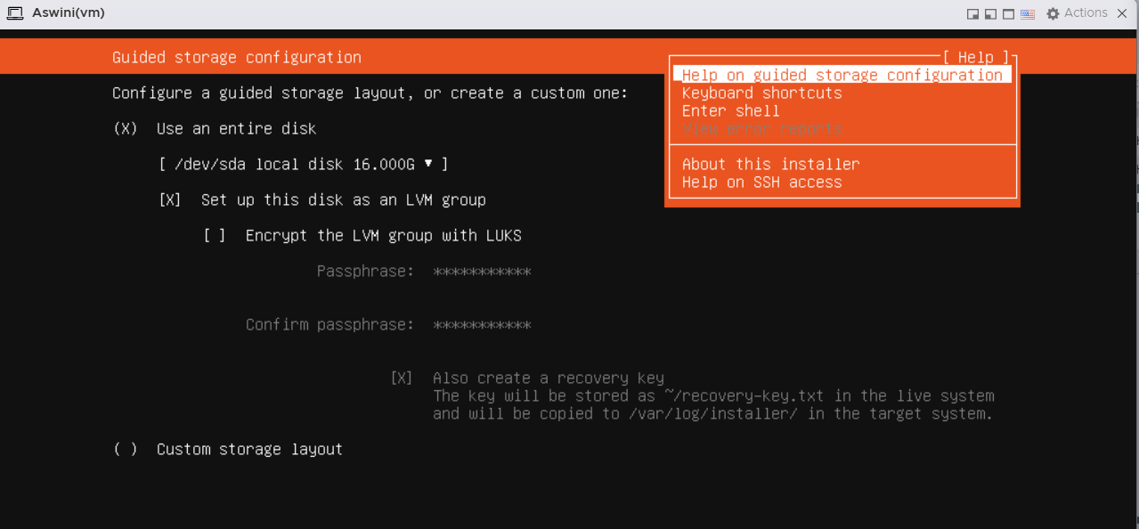

* Then Os installed and Now we can use this Vm

